CISCO AnyConnect
Installation Guide
Below are two steps, Step 1 is to install CISCO AnyConnect and configure, and Step 2 is to access the QIES site.
Please DO NOT click on any links in these instructions. Please copy and paste.
Contents:
- Compatibility Guide: Listing of all supported computer operating systems.
- Step 1: Installing and configuring CISCO AnyConnect.
- Step 2: Accessing the QIES site.
IMPORTANT NOTE:
- For QIES users with the existing Cisco Secure client:
- Login Process:
- Enter the VPN URL: qies-west.cms.gov or qies-east.cms.gov.
- Log in using your existing CMSNet user ID and password. (Usually the one begging with a “C” followed by 6 numbers.)
IMPORTANT NOTE Upgrade Process:
If the Cisco Secure Client is not on version 5.1.12.146, it will automatically start the upgrade process to this version.
After the upgrade, a message will pop up stating that this is restricted access. Log out and log back in with the new profile.
Profile Selection:
Two additional profiles will be available: qies-west.cms.gov and qies-east.cms.gov.
Select qies-west.cms.gov or qies-east.cms.gov and log back in to establish the connection. You will no longer receive the restricted access message.
The additional profiles will not overwrite any existing profiles on the client.
Sign-In Notification:
Caveat: If the current Cisco Secure VPN client is locked down by corporate admins, users will need to:
Contact the admins to permit the upgrade to version 5.1.12.146 and allow a new profile to be added. The client profile will be automatically downloaded when the user logs in after the upgrade.
Ensure the existing profile remains untouched and available.
The admins will need to validate that the new client version will work with their existing corporate VPN solution.

Compatibility Guide:
Cisco Secure Client 5.1.12.146 supports the following operating systems.
- Windows:
- NOTE: As of November 15TH 2025, WINDOWS 10 IS NO LONGER SUPPORTED.
- Windows 11 (64-bit)
- Windows 11 for ARM64-based PCs (Supported only in VPN client, DART, Secure Firewall Posture, Network Visibility Module, Umbrella Module, ISE Posture, and Zero Trust Access Module)
- MAC:
- macOS (64-bit only) ν macOS 15 Sequoia
- macOS 14 Sonoma
- macOS 13 Ventura
- APPLE iOS:
- Cisco Secure Client 5 is the latest and recommended version available on all iPhones, iPads, and iPod Touch devices running Apple iOS 13.0 and later.
- Cisco Secure Client 5 is the latest and recommended version available on all iPhones, iPads, and iPod Touch devices running Apple iOS 10.3 and later.

CHROME BOOKS/Androids:
Full support for Cisco Secure Client on Android is provided on devices running Android 4.0 (Ice Cream Sandwich) through the latest release of Android. In order to use the Umbrella module for Cisco Secure Client for Android, you must have Android 6.0 or later. For all current Chromebooks, Cisco Secure Client for Android is officially supported and strongly recommended for the optimal Cisco Secure Client experience on ChromeOS. The native ChromeOS client is intended only for legacy Chromebooks incapable of running Android applications.

NOTE: If Step 2 is not functioning and you are connected to CISCO AnyConnect, it may be necessary to uninstall and reinstall the software. If CISCO AnyConnect software is not installed, proceed to Step 1. If CISCO AnyConnect is already installed, proceed to Step 2.

Step 1: INSTALL CISCO ANYCONNECT:
- Login as an ADMINISTRATIVE USER (Ability to install and uninstall programs on your PC. Normally your IT Dept.)
Note: Power user and elevated users usually will NOT allow access to install/uninstall programs.
- COPY / PASTE one of the following websites into a web browser of your choice. (Supported browsers are Microsoft Edge, Google Chrome, or Firefox. Internet Explorer 11 is no longer supported.) The Installer will automatically download when you enter the link in a browser.

Windows:
COPY / PASTE the following website into a web browser. (Supported browsers are Microsoft Edge, Google Chrome, or Firefox.) The Installer will automatically download when you enter the link in a browser.
Facilities WEST of the Mississippi will use:
- https://qies-west.cms.gov

Facilities EAST of the Mississippi will use:
- https://qies-east.cms.gov
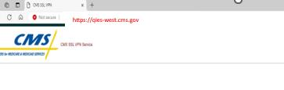

- Enter your CMS Net ID and Password. (Usually the one begging with a “C” followed by 6 numbers.)
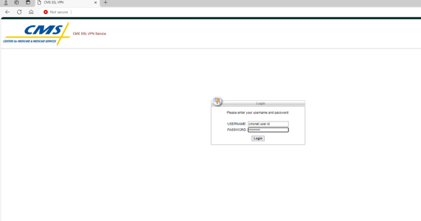

- Note: If prompted to reset a password, enter the information and click “continue.”
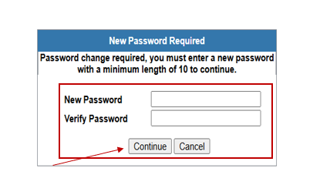
- Click “Continue” on the warning prompt.
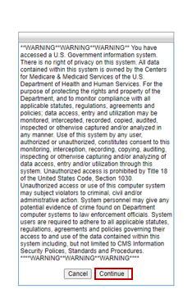
- Click download for “Windows.”
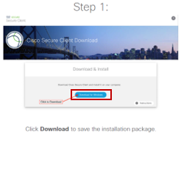
- Go to your Downloads and Click “Open File.”
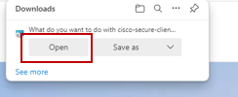
- Open Windows Folders for Files and select “This PC”, then launch the install package.
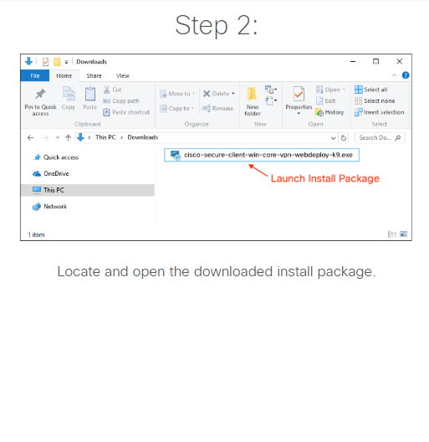

- On the set up click “Next.”
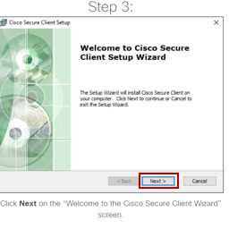
- Accept Terms and Conditions and click “Next.”
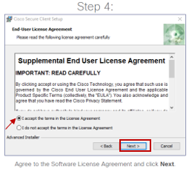
- Click “Install.”
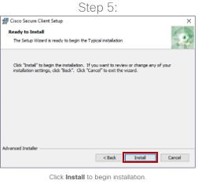

- Select Yes to proceed with installation.
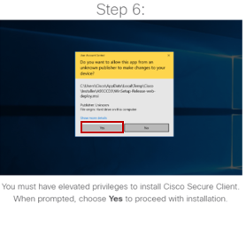
- Click “Finish.”
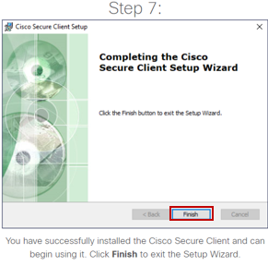
- Launch Cisco Secure from “Start Menu.”
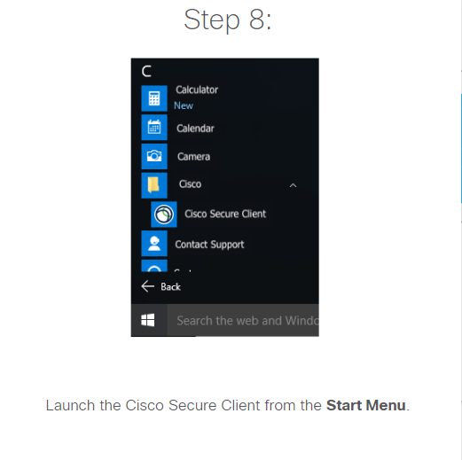
Enter qies-west.cms.gov
Or
qies-east.cms.gov
NOTE: Facilities WEST of the Mississippi River will use QIES-WEST Facilities EAST of the Mississippi River will use QIES-EAST This is strictly for load balancing. It will not affect your submission. If the West is down, you can use the East and vice versa.

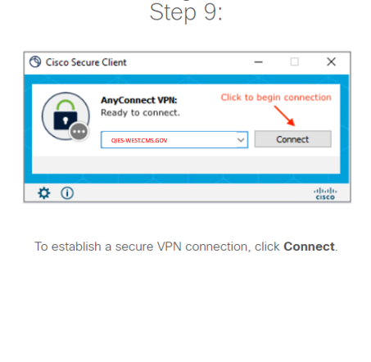
- Click “Connect”.

- Important: First time connecting you will get this message.
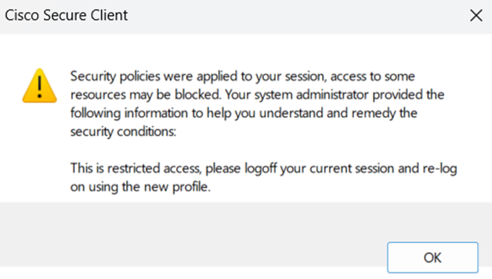
- Per that message, disconnect, reconnect using qies-west.cms.gov or qies-east.cms.gov in the drop-down menu.
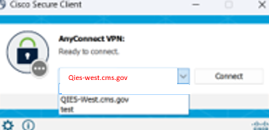
Qies-east.cms.gov
- Click “Connect”.

MAC OS:

NOTE: CANNOT USE SAFARI. YOU WILL NEED TO INSTALL GOOGLE CHROME OR MICROSOFT EDGE.
Facilities WEST of the Mississippi will use:
- https://qies-west.cms.gov

Facilities EAST of the Mississippi will use:
- https://qies-east.cms.gov
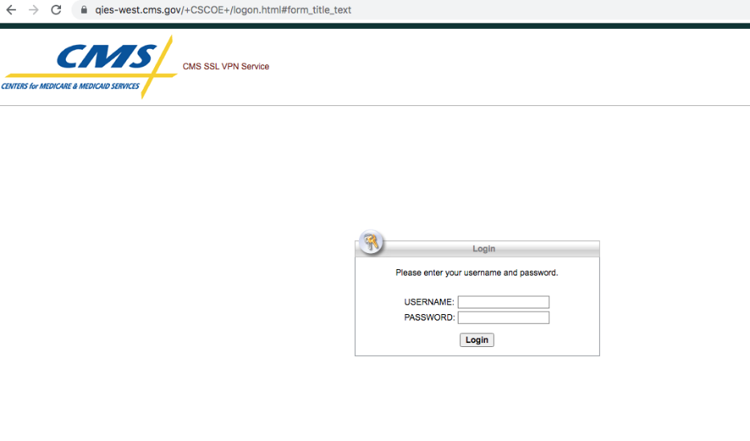
- Enter Your CMSNet User ID and Password. (Usually the one begging with a “C” followed by 6 numbers.)
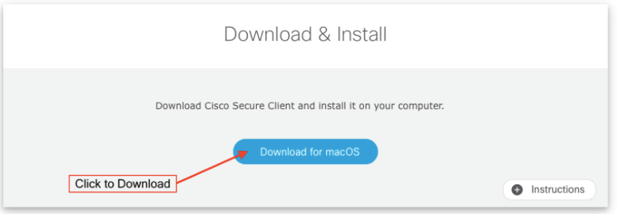
- Click “download for macOS” button to save install package.
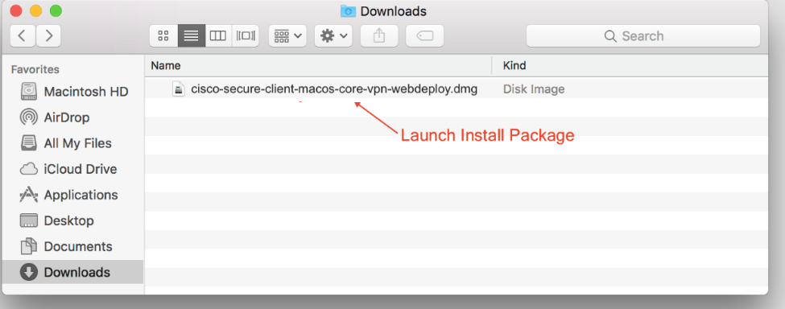
- Locate and open the downloaded file.
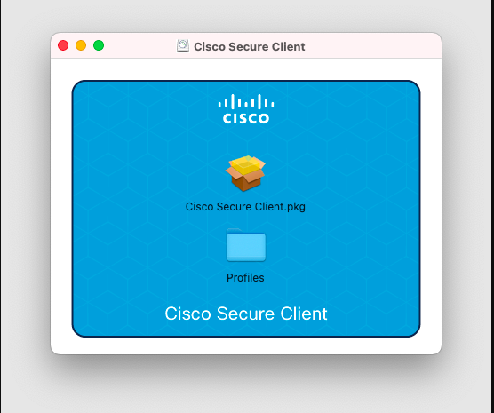
- The file will mount a disk image. Open this disk image and launch the name “Cisco-Secure-Client-MAC OS-XXXXXXX”.
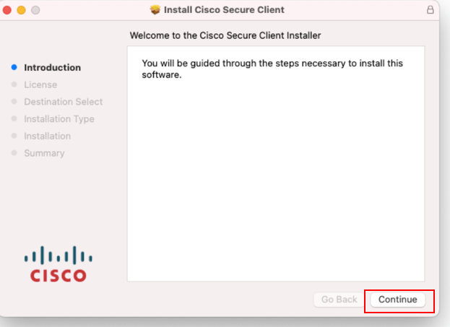
- Click “Continue” this “Welcome to the Cisco Secure Client Installer” screen.
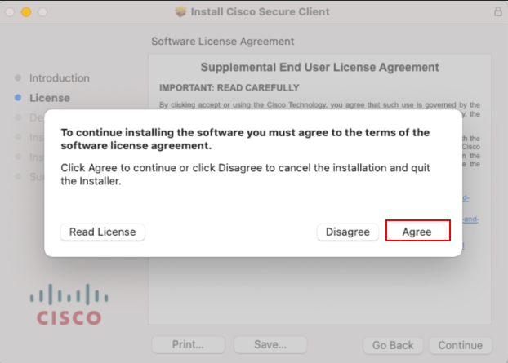
- Click “Continue” the software license agreement screen and this click “Agree” on the slide down dialog.
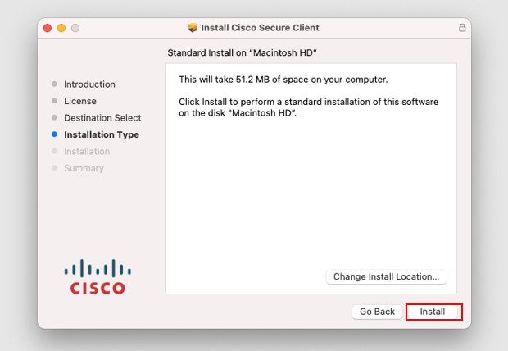
- Click “Install” to begin installation.
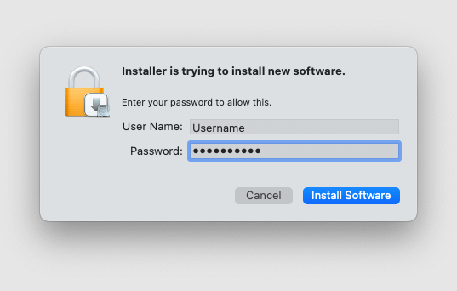

- Click Install to begin installation. Because Cisco Secure Client requirements admin privileges, enter your device’s password to install.
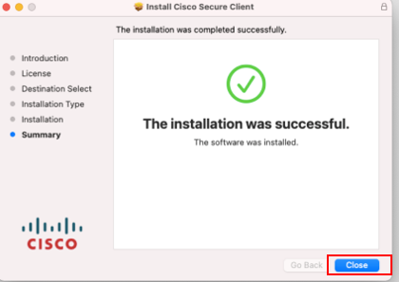
- You have successfully installed the cisco secure client and is now ready for use, Click “Close”.
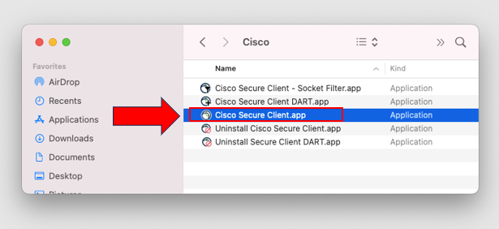
- To open the CISCO Secure client, browse to your application folder and double click.

Enter qies-west.cms.gov
Or
qies-east.cms.gov
- NOTE: Facilities WEST of the Mississippi River will use QIES-WEST Facilities EAST of the Mississippi River will use QIES-EAST This is strictly for load balancing. It will not affect your submission. If the West is down, you can use the East and vice versa.

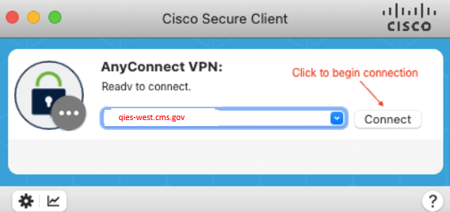
- Click “Connect”.
- Important: First time connecting you will get this message.
- Per that message, disconnect, reconnect using qies-west.cms.gov or qies-east.cms.gov in the drop-down menu.
Qies-east.cms.gov
- Click “Connect”.

Mobile clients: (including Chrome Books) To install:
For Android devices:
- Visit the Play store on the device .
- In the search bar, search for Cisco Secure or Cisco AnyConnect .
- Click on “Install” and install the app 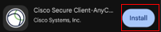.
- Once installed, open the AnyConnect app.
- Within the app, click on “Connections”, should bring you to a page to “Add a Connection”
- Click “+” icon in the bottom right corner and in the “Description” field, type “QIES VPN”, in the “Server Address” field, type “qies-west.cms.gov” or qies-east.cms.gov. Leaving the rest as default. Click on “Done”.
- Verify the QIES VPN (just create) is checked.
- Click on the “<-” icon on the “Connection Selector” located on the top menu bar.
- Verify “Connections” row shows “QIES VPN”. When verified, click the toggle button on the “AnyConnect VPN” row.
- Enter your CMSNet username and password and log in. Accept the banner message.
- Important: First time connecting you will get this message.
- Per that message, disconnect by toggling the “AnyConnect VPN” button.
- After it disconnect, it will automatically update the “Connections” list, click on the “Connections” row and enter the “VPN Connections” view. From there, select the qies-west.cms.gov or qies-east.cms.gov and ensure that connection is checked and enabled. Once verified, click on the “Home” icon on the bottom menu.
- Check that the “Connections” now say qies-west.cms.gov or qies-east.cms.gov, if it does, then toggle the “AnyConnect VPN” button to connect.
- Enter your CMSNet username and password and log in. Accept the banner message and continue to STEP 2.

For Apple iOS devices:
- Visit the Apple App Store and search for Cisco Secure or Cisco AnyConnect.
- Click on “Get” and install the app.
- Once installed, open the Cisco Secure Client app.
- Within the app, click on “Connections”, should bring you to a page to “Add VPN Connection…”
- Click “Add VPN Connection…” and in the “Description” field, type “QIES VPN”, in the “Server Address” field, type “qies-west.cms.gov” or qies.east.cms.gov. Leaving the rest as default. Click on “Save” on the upper right corner. Click on “Allow” to the pop-up message to add VPN configuration. Put in your pin to unlock your phone if requested.
- Verify the QIES VPN (just create) is checked and enabled.
- Click on the “Home” icon on the bottom menu bar.
- Verify “Connections” row shows “QIES VPN”. When verified, click the toggle button on the “AnyConnect VPN” row.
- Enter your CMSNet username and password and log in. (Usually the one begging with a “C” followed by 6 numbers.)
- Accept the banner message.
- Important: First time connecting you will get this message.
- Per that message, disconnect by toggling the “AnyConnect VPN” button.
- After it disconnect, it will automatically update the “Connections” list, click on the “Connections” row and enter the “VPN Connections” view. From there, select the qies-west.cms.gov or qies-east.cms.gov and ensure that connection is checked and enabled. Once verified, click on the “Home” icon on the bottom menu.
- Check that the “Connections” now say qies-west.cms.gov, or qies-east.cms.gov if it does, then toggle the “AnyConnect VPN” button to connect.
Enter your CMSNet username and password and log in. (Usually the one begging with a “C” followed by 6 numbers.)
- Accept the banner message and continue to STEP 2.

STEP 2: ACCESSING CMS
DO NOT click on any of the links below:
- Open a Web Browser of choice (Microsoft Edge, Google Chrome, or Firefox.)
- COPY and PASTE the appropriate URL.
- For MDS/PBJ: https://web.qiesnet.org/qiesmds/mds_home.html
- For SWB: https://web.qiesnet.org/qiessb/home.html
- For HOSPICE: https://web.qiesnet.org/qieshospc/home.html
- Save the site as a bookmark or shortcut if desired.
- Once you access the above URLs, you will need to direct any questions to the QIES Helpdesk at 1-800-339-9313 or iqies@cms.hhs.gov (Screen shots are below) .
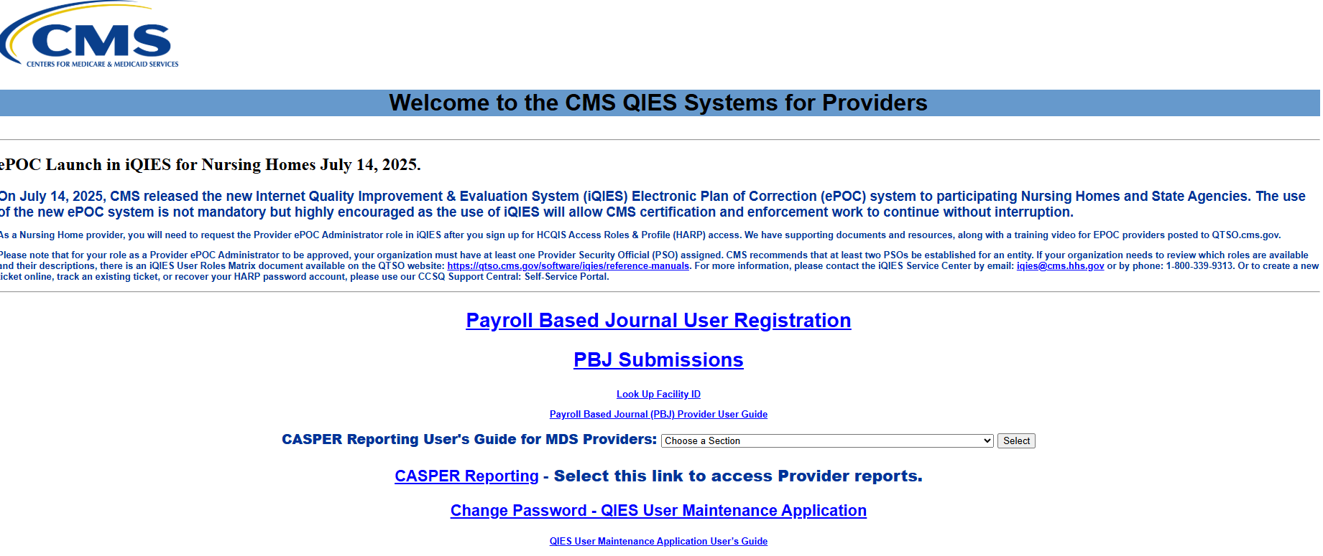

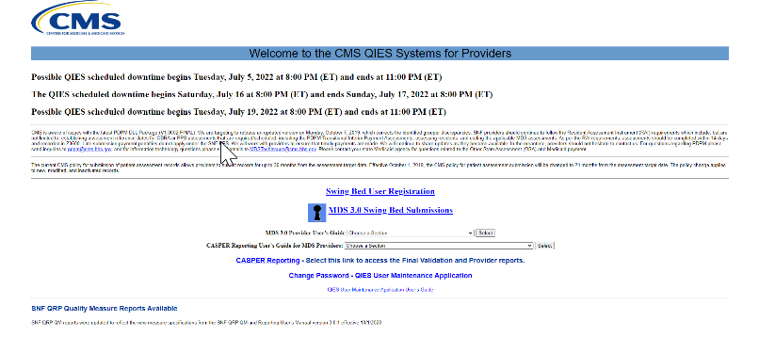

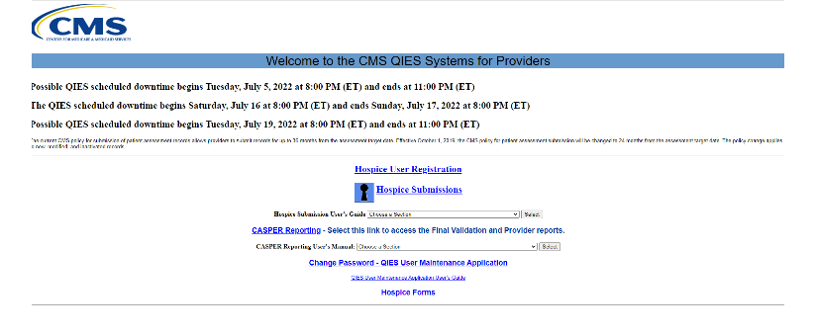
Once you receive any of the above screens all questions should be directed to QIES Helpdesk at 1-800-339-9313 or iqies@cms.hhs.gov.

If you are having issues, please contact the CMSNet Remote User Support helpdesk.
Phone: (888) 238-2122 or E-mail: MDCN.MCO@PALMETTOGBA.COM

